horizontal line

EE208:CONTROL ENGINEERING LAB 06

# State feedback controller design on MATLAB platform.

## 

## Course Instructor : Dr. Sanjay Roy

## Date : 19th February 2022



## Group Number - 14

## 

## Raj Kumar Deb 2020eeb1025

## Tushar Sharma 2020eeb1325

## Tiya Jain 2020eeb1213

# 

# 

# 

# TABLE OF CONTENTS

**1. OBJECTIVE** **3**

**2. GIVEN** **3**

2.1 GIVEN BLOCK DIAGRAM 3

2.2 GIVEN DESIGN SPECIFICATIONS 4

**3. THEORY** **4**

3.1 CLOSED LOOP TRANSFER FUNCTION BLOCK DIAGRAM 4

3.2 TRANSFER FUNCTION 5

**4. OBSERVATIONS & THEIR ANALYSIS** **5**

4.1 ANALYSIS ON GIVEN STATE SPACE MATRIX 6

4.1.1 State space matrix 6

4.1.2 EIGENVALUES OF A 6

4.1.3 STEP RESPONSE 7

4.2 VARIATION IN POLES USING POLE PLACEMENT DESIGN: 7

4.2.1 REAL POLES 7

4.2.2 PURELY IMAGINARY 8

4.2.3 COMPLEX POLES 8

4.3 RECORDING & ANALYSIS OF COMBINATIONS OF FEEDBACK GAINS 10

4.3.1 Condition 1 + Condition 2 10

4.3.2 Condition 1 + Condition 3 10

4.3.3 Condition 2 + Condition 3 10

4.3.4 Condition1 + Condition 2+ Condition 3 10

4.4 SETTLING TIME TREND ANALYSIS 11

4.5 FINAL SELECTION OF FEEDBACK GAIN K 11

**5. CONCLUSION** **12**

**6. MATLAB SCRIPTS** **12**

# 

# 1. OBJECTIVE

* To design the state feedback gain matrix for a given analog state-space system to satisfy required performance specifications.

# 2. GIVEN

## 2.1 GIVEN BLOCK DIAGRAM

###### 

#### Figure 2.1.1 Block diagram for the OLTF of the given system

## 2.2 GIVEN DESIGN SPECIFICATIONS

State feedback gain matrices are to be designed so that:

* **Condition 1:** Settling times of individual states are retained at those of the nominal eigenvalues.
* **Condition 2:** Maximum magnitude of all eigenvalues are as in the nominal set.
* **Condition 3:** The CL system is always observable and controllable.

# 3. THEORY

## 3.1 CLOSED LOOP TRANSFER FUNCTION BLOCK DIAGRAM

### 

#### 

#### Figure 3.1.1 Block diagram for the CLTF of the given system

*\*\*The schematic shown above where K is a matrix of control gains. Note that here feedback all of the system's states, rather than using the system's outputs for feedback.*

# 

## 3.2 TRANSFER FUNCTION

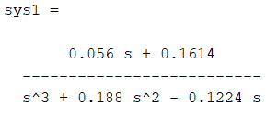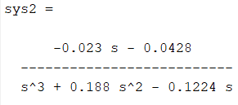

#### Figure 3.2.1 Transfer function of the two systems of the open loop.

# 4. OBSERVATIONS & THEIR ANALYSIS

Upon linearisation about a nominal operating point, the analog system is characterized by the following matrices:

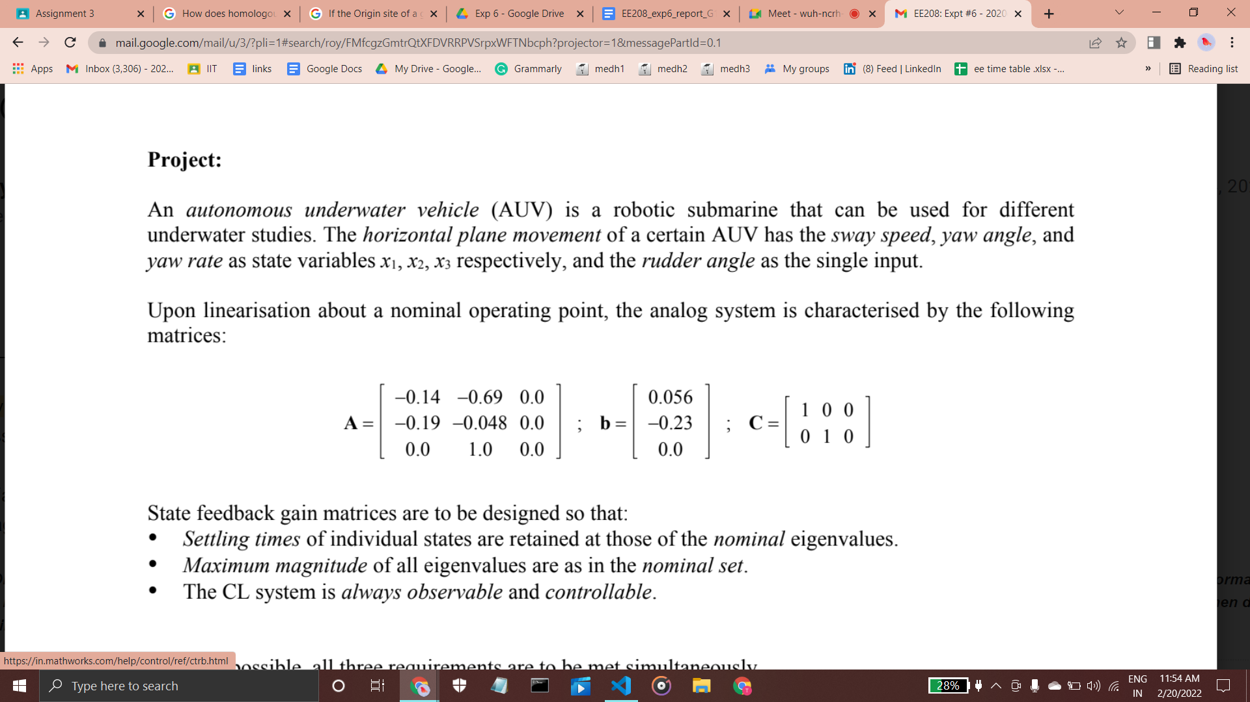

## 4.1 ANALYSIS ON GIVEN STATE SPACE MATRIX

### 4.1.1 STATE SPACE MATRIX

### 

#### Figure 4.1.1 Closed Loop Transfer Function of the given system

### 

### 4.1.2 EIGENVALUES OF A

From the theory, we calculated the eigenvalues of matrix A , which also denote the poles of the open loop system matrix. These were found to be **0 , 0.2701 , -0.4590.** We infer from these values that the OLTF system is **unstable** and therefore no satisfactory conclusion was drawn from this result. Now we need to add a Feedback Gain K matrix to make the system stable and fulfill all the conditions.

### 4.1.3 STEP RESPONSE

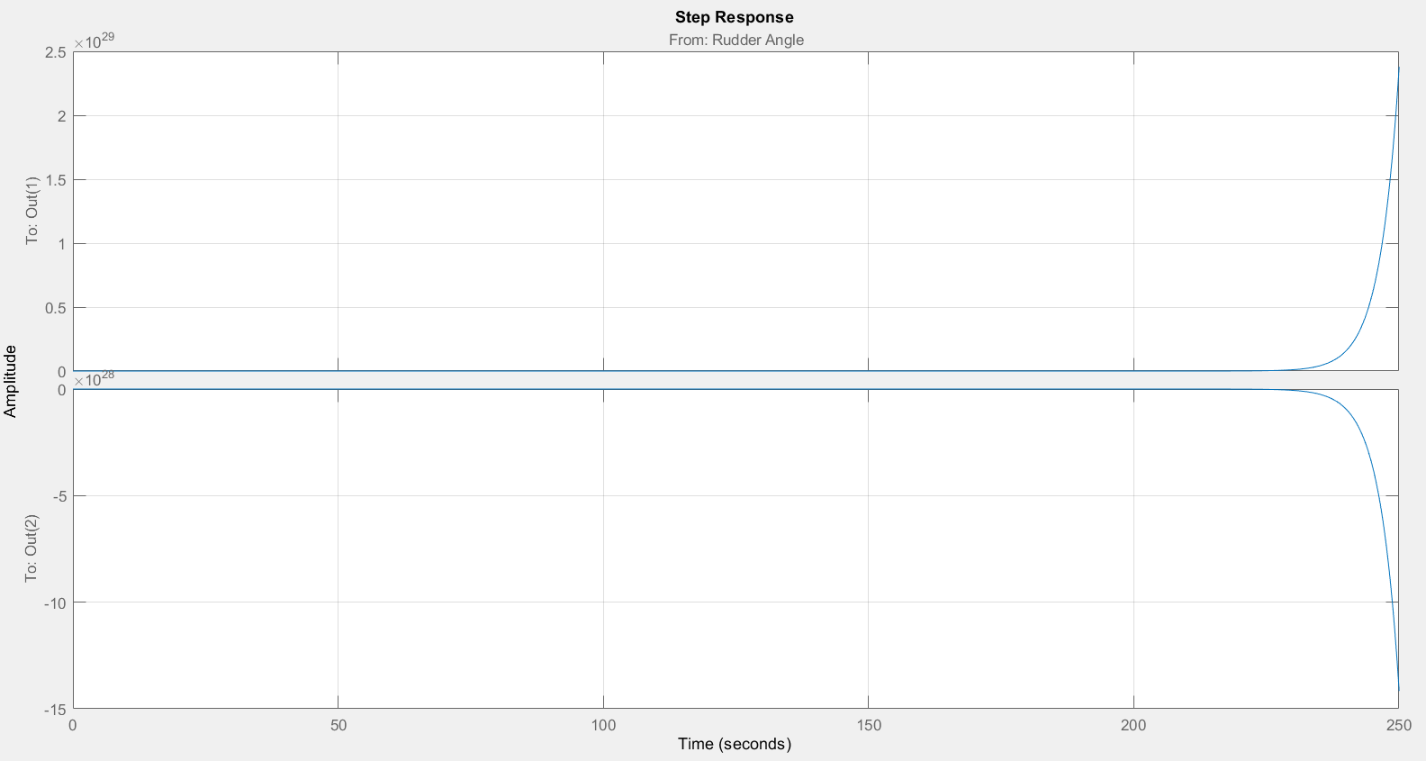

#### Figure 4.1.2 Step Response of the OLTF of the given system

## 

## 4.2 VARIATION IN POLES USING POLE PLACEMENT DESIGN:

After the analysis of the eigenvalues of the given function, our next step naturally was to change the poles of the given function with the help of a feedback gain matrix. But now the question was which kind of poles we should be taking?? So, we started by taking simple real poles.

### 4.2.1 REAL POLES

From MATLAB, we analyze all results obtained and we come to a conclusion that the proper settling time can’t be reached without an imaginary part present in it.

For example, poles at -1.9829, -0.4682, +0.3230 have no settling time (NaN). Therefore we shift our focus towards purely imaginary or conjugate pairs.

### 

### 4.2.2 PURELY IMAGINARY

We have a pole constituting of real and complex part, as the real part of any pole portrays the rate of decay and if we don't have that which is evident in case of purely imaginary values of poles, we may observe a system that is completely oscillating and thus our AUV (even when given a small jerk) in the ruddle angle will start to oscillate which is not a desirable condition.

### Hence we now look for complex conjugate pole pairs to satisfy our conditions

### 

### 4.2.3 COMPLEX POLES

#### Table 4.2.3.1

| **k1** | **k2** | **k3** | **Settling Time 1** | **Settling Time 2** |
| --- | --- | --- | --- | --- |
| 0.145 | -4.973 | -2.134 | 10.765 | 9.227 |
| 0.362 | -4.486 | -1.707 | 15.240 | 9.253 |
| 0.579 | -3.998 | -1.280 | 20.200 | 7.435 |
| 0.796 | -3.510 | -0.853 | 31.572 | 8.359 |
| 1.013 | -3.023 | -0.427 | 61.838 | 9.526 |

#### Table 4.2.3.2

| **k1** | **k2** | **k3** | **Settling Time 1** | **Settling Time 2** |
| --- | --- | --- | --- | --- |
| 0.145 | -4.973 | -2.134 | 10.765 | 9.227 |
| 0.155 | -4.973 | -2.134 | 10.825 | 9.197 |
| 0.255 | -4.973 | -2.134 | 11.477 | 8.832 |
| 0.355 | -4.973 | -2.134 | 12.243 | 5.847 |
| 0.955 | -4.973 | -2.134 | 17.834 | 6.601 |

#### Table 4.2.3.3

| **k1** | **k2** | **k3** | **Settling Time 1** | **Settling Time 2** |
| --- | --- | --- | --- | --- |
| 0.955 | -4.973 | -2.134 | 17.834 | 6.601 |
| 0.955 | -4.573 | -2.134 | 17.784 | 6.629 |
| 0.955 | -4.073 | -2.134 | 17.739 | 6.611 |
| 0.955 | -3.573 | -2.134 | 17.660 | 8.456 |
| 0.955 | -3.073 | -2.134 | 17.481 | 10.566 |

* In the open transfer function, we could not obtain a settling time because the system was unstable. So, the settling time that is observed by enclosing the system in a gain K represents that the system has been stabilized and it satisfies the settling time conditions.
* We applied the above condition for settling time taking into consideration the magnitude constraint **(keeping overall magnitude less than 0.4590)**  as we restricted our complex conjugate poles in such a manner such that their magnitude falls in the bounded range of magnitude of nominal eigenvalues.
* We observe that the settling time of system 1 reduces as we reduce the magnitude of k2, and increases for increasing the magnitude of k1.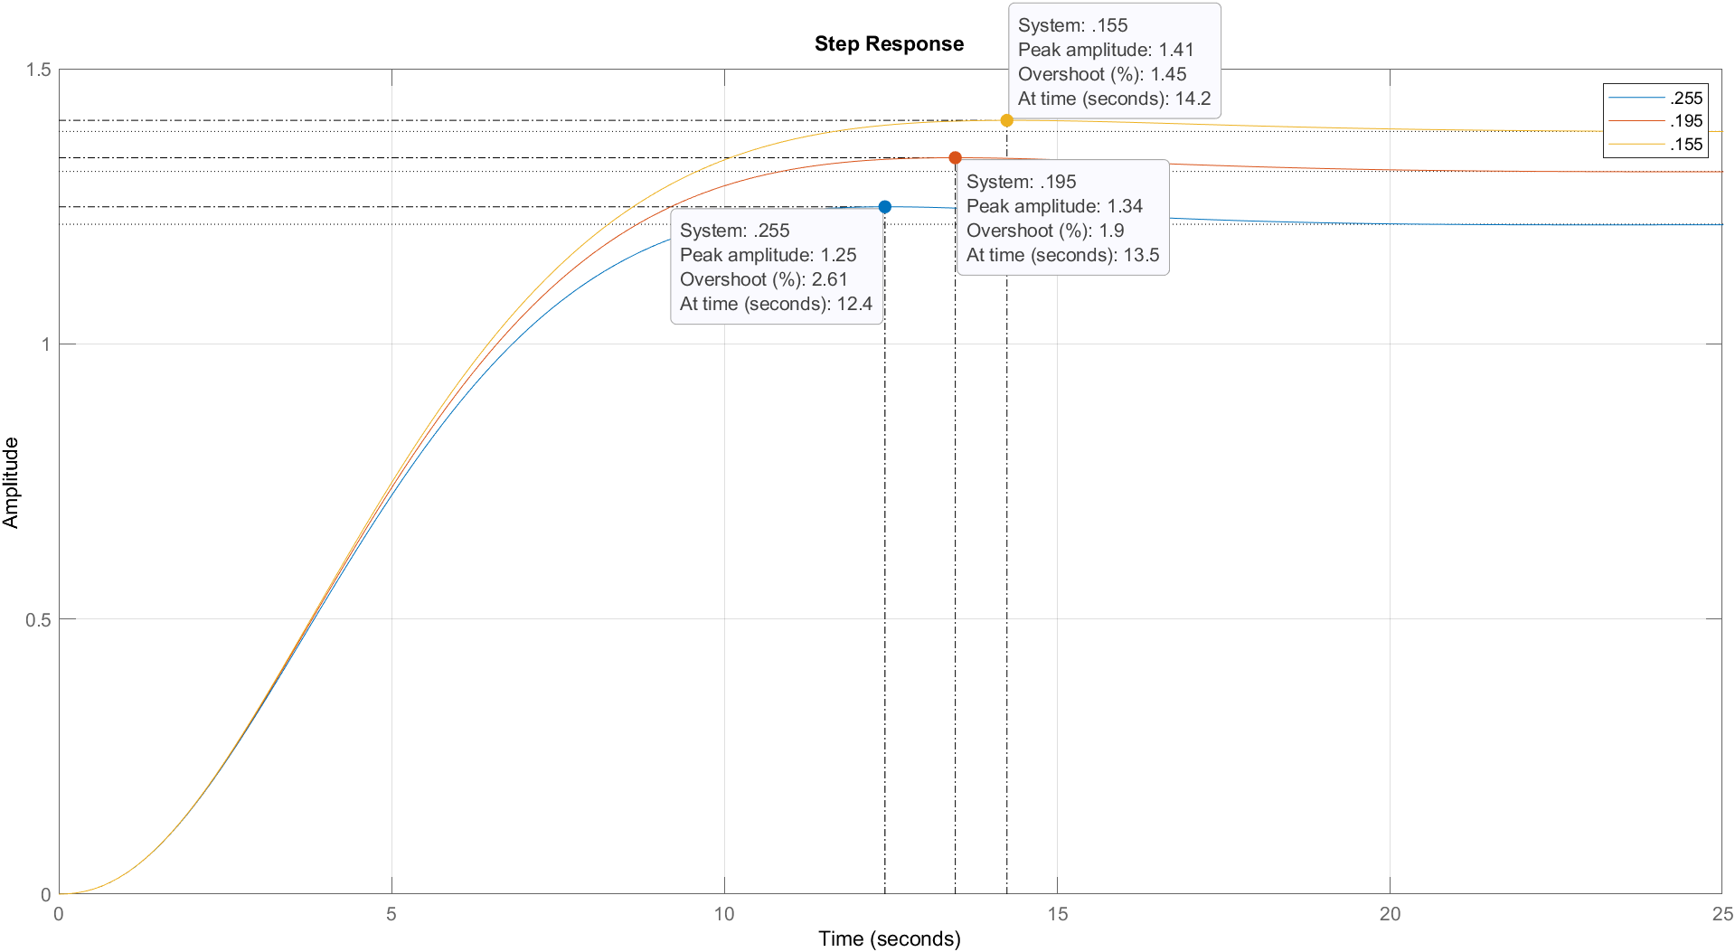

#### Figure 4.2.3.1 Step Responses Vs k1

* From the above graph of multiple step responses, we can observe that the overshoot increases as the gain K1 is increasing.
* The peak is achieved earlier for increasing the value of K1, maintaining an inverse relationship with the Gain, also the peak is smaller for larger values of Gain.

## 4.3 RECORDING & ANALYSIS OF COMBINATIONS OF FEEDBACK GAINS

### 4.3.1 Condition 1 + Condition 2

Since in the previous section we observed that the observed values of settling time were picked from only those values of poles which followed magnitude constraints . Thus we can say there is a strong dependence of condition 1 on condition 2.

Thus they both can be fulfilled simultaneously.

***Note -*** *It may be noted that the value of settling time can be observed in other ranges of complex poles as well, but those complex values may not be falling in our magnitude constraints.Thus we ignore that domain of values.*

### 4.3.2 Condition 1 + Condition 3

Since the definition of *contrabillity* tells us that our system shall be able to move from a particular finite state to another finite state. Within a finite number of steps.however,this trend was not always observed because the values of step responses of the states (sway speed and yaw angle) were not *stabilizing* to a stable value for certain values of feedback gain matrix K. Thus we can say condition 1 and condition 3 may not hold true simultaneously for the entire range of complex poles taken in our range.

### 4.3.3 Condition 2 + Condition 3

Similar to previous observations the conditions of controllability and observability were not met for the entire range of complex poles we took.

### 4.3.4 Condition1 + Condition 2 + Condition 3

They may not hold together as we have mentioned in the above sections 4.3.1, 4.3.2 and 4.3.3 .

## 

## 4.4 SETTLING TIME TREND ANALYSIS

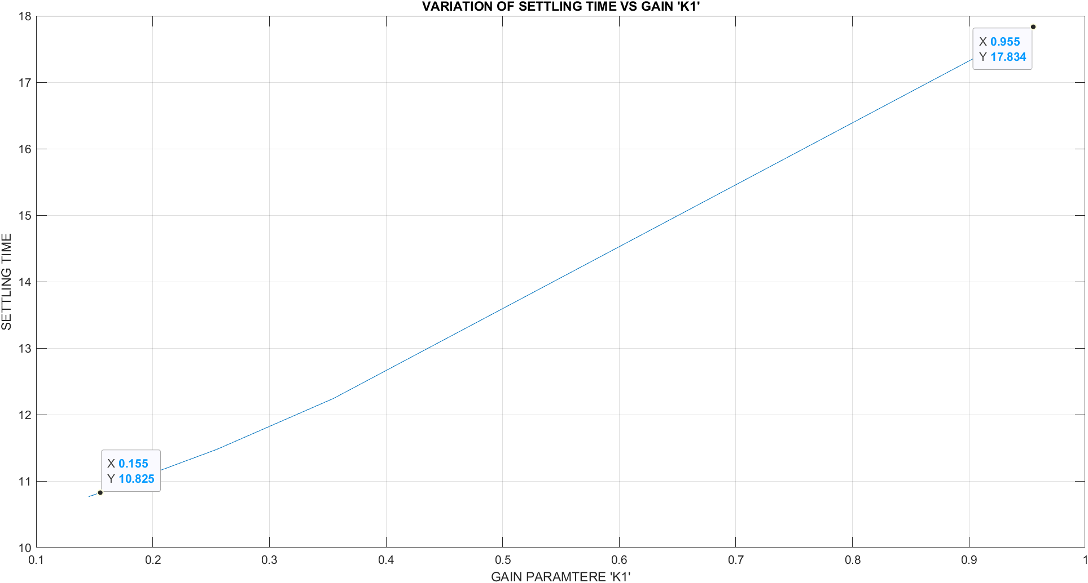

#### Figure 4.4.1 Variation of settling time 1 wrt Gain Parameter ‘K1’

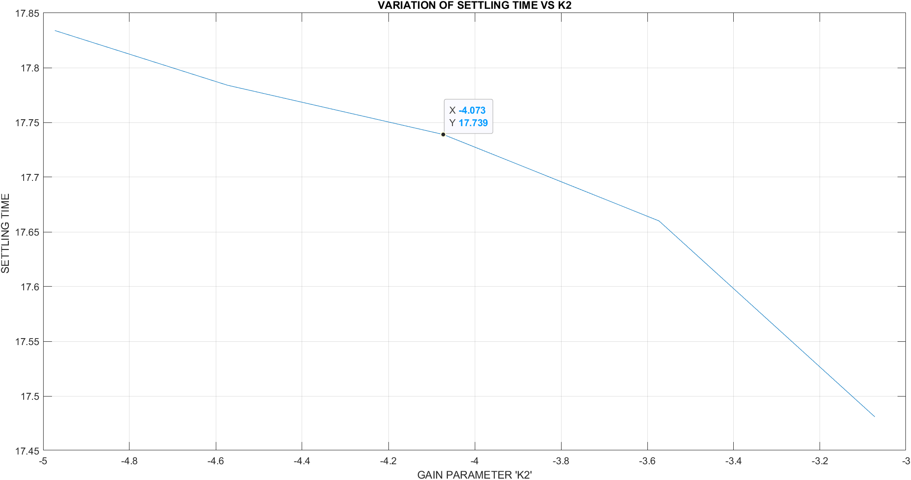

#### Figure 4.4.2 Variation of settling time 1 wrt Gain Parameter ‘K2’

## 

## 4.5 FINAL SELECTION OF FEEDBACK GAIN K

We selected the value of feedback gain which gave us the minimum value of settling time for both the systems. So the **feedback gain K = [ 0.145 -4.973 -2.134]**. For this the step responses had settling time less than given nominal value.

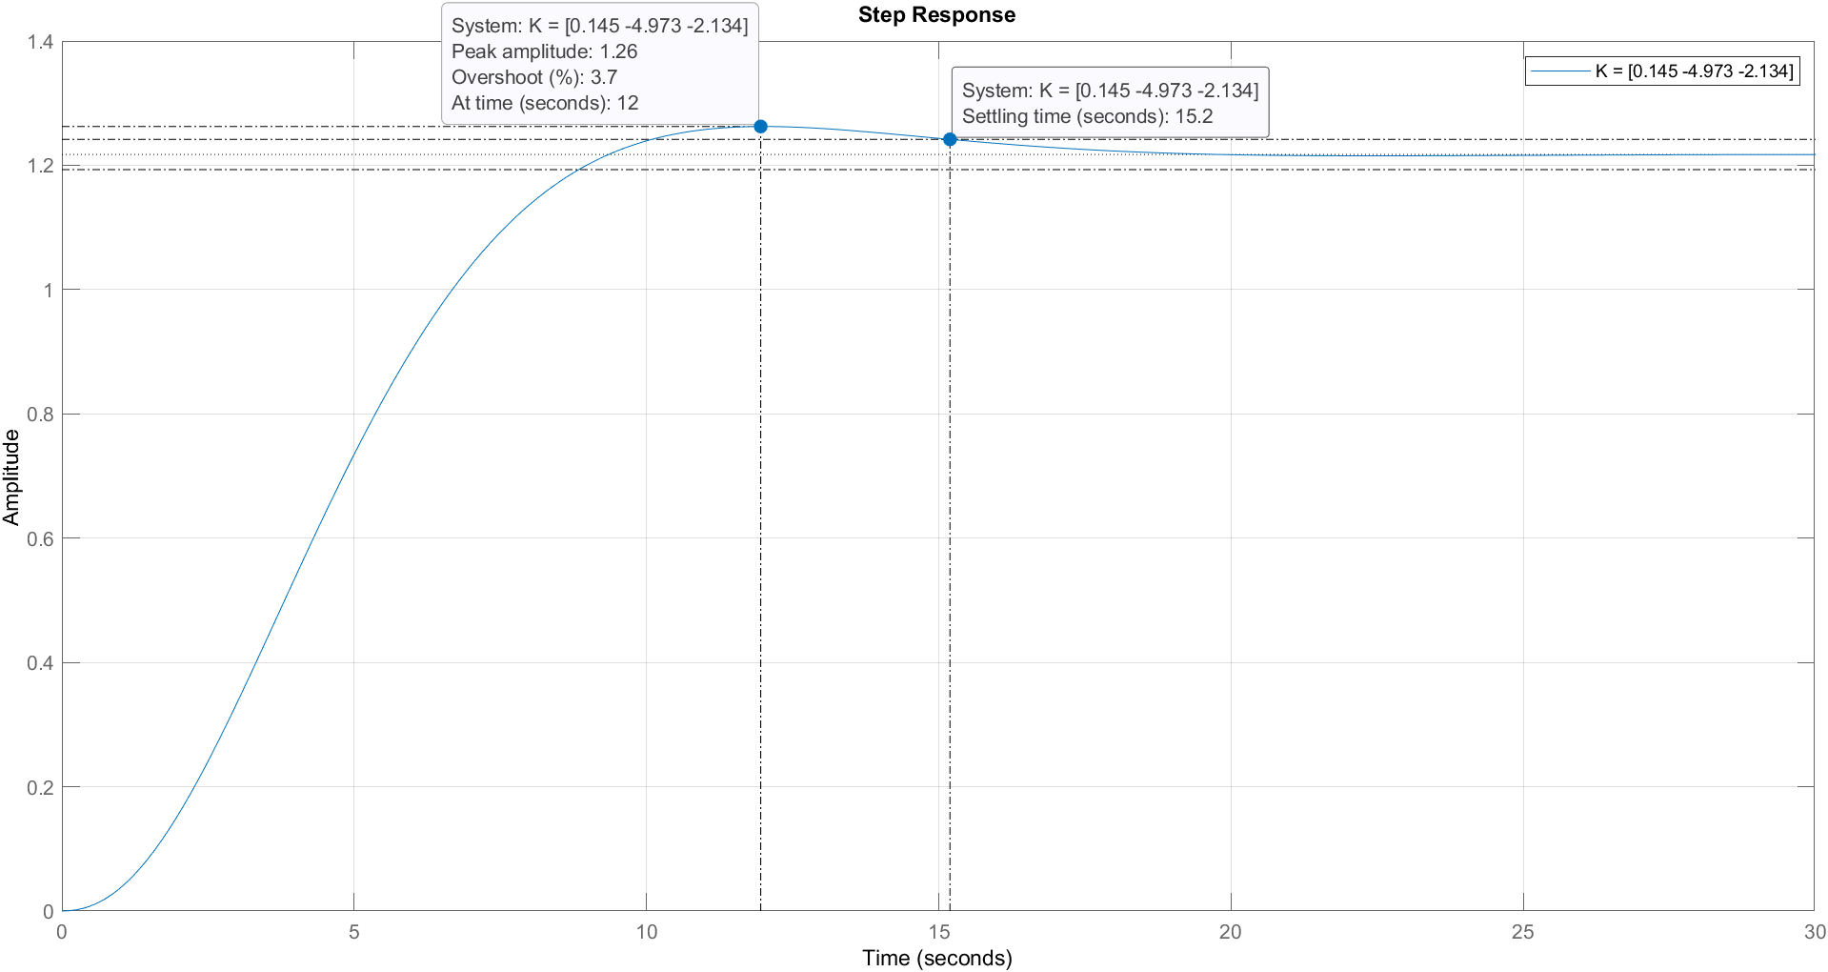

#### Figure 4.5.1 Step Response of our selected feedback gain

# 5. CONCLUSION

* We varied the values of poles and observed the values of gain matrices K and then observed the settling time and step responses of the closed loop transfer functions.
* We can conclude that making the system observable and controllable at the same time following the other conditions was hardly possible according to our observations and simulations.
* However after going through a lot of iterations we found the most suitable value of the gain matrix **K = [ 0.145 -4.973 -2.134]** such that the whole system was **observable and controllable**. At the same time , the magnitude constraint was also followed **(<0.4590)** for all poles. In addition, we obtained a pretty good settling time of **10.765 sec** (for first transfer function) and **9.227 sec** (for second transfer function).

# 6. MATLAB SCRIPTS

